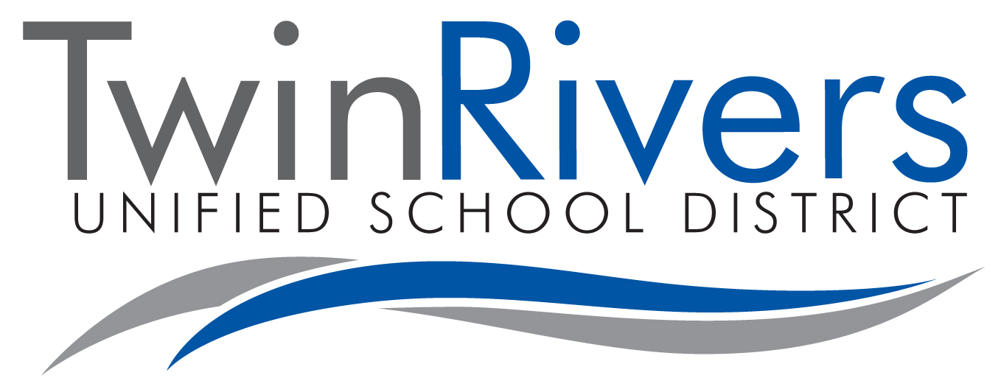
HEALTH QUESTIONNAIRE

SITE: ◻ Morey ◻ Oakdale ◻ Rio Linda ◻ Village
CHILD’S NAME: ________________________________________________ DATE OF BIRTH: ___________________

Please answer the following questions to assist us in anticipation of your child’s needs:

- Does your child have an ongoing illness? If yes, check all that apply: ◻ Yes ◻ No
◻ Asthma ◻ Diabetes ◻ Seizures
◻ Sickle Cell Anemia ◻ Heart Condition ◻ Severe Allergies (bees, etc.)
◻ Other: _____________________________________________________________

2. Does your child take any prescribed medication? If yes, please list the following: ◻ Yes ◻ No
Medication: _________________________ For (diagnosis): ____________________
Prescribed by Dr: ____________________________ Phone: ____________________
If yes, does medication need to taken during school hours? ◻ Yes ◻ No

- Has your child ever tested positive for TB? ◻ Yes ◻ No
If yes, is he/she taking or ever taken INH medication? ◻ Yes ◻ No
Date of last x-ray: ______________________________

- Does your child have a clinically-diagnosed disability? If yes, check all that apply: ◻ Yes ◻ No
◻ Speech/Language Therapy ◻ Physical Therapy ◻ Occupational Therapy
◻ Mental Health Services ◻ Vision Impairment ◻ Hearing Impairment
◻ Dietitian Services ◻ Other: __________________________________

- Does your child have a current Individual Education Plan (IEP) or Individual Family Service ◻ Yes ◻ No
Plan (IFSP)? If yes, please provide staff with a current copy.

6. Is your child/family currently receiving services from Alta Regional? ◻ Yes ◻ No
If yes, please state reason: _________________________________________________

7. Is your child in Foster Care? ◻ Yes ◻ No
If yes, Social Worker’s Name: ___________________________ Phone:______________

- Is your child allergic to any food product or does he/she require a special diet? ◻ Yes ◻ No
If yes, please list foods: ____________________________________________________
Physician’s name: ________________________________ Phone: _________________

- Does your child have feeding problems that would prevent him/her from eating the Head ◻ Yes ◻ No
Start meals or does he/she require adaptive equipment, including feeding utensils?
If yes, please list: ________________________________________________________
________________________________________________________

10. Is your child/family currently receiving services from any agencies? Check all that apply: ◻ Yes ◻ No
◻ CCS ◻ Department of Social Services ◻ WEAVE
◻ CPS ◻ Food Stamps - Case #_______________ ◻ WIC

11. For Preschool Children: Does your child need assistance with toileting? ◻ Yes ◻ No
(Your response will not prohibit enrollment in Head Start. If your child is not toilet trained,
his/her needs will be discussed with you.)

12, Has your child previously been enrolled in Head Start or Early Head Start? ◻ Yes ◻ No
If yes, which agency? _____________________________________

___________________________________________ __________ ______________________________________________________
1st Year Parent/Guardian signature Date 1st Year Staff signature Date

___________________________________________ __________ ______________________________________________________
2nd Year Parent/Guardian signature Date 2nd Year Staff signature Date

(Rev. 02/2020)
If “Yes” to any of the above questions, please provide documentation verifying the condition/referral.

